**NoSQL databases:**

Originally named with reference to Non-relational databases, nowadays people consider NoSQL as “not only SQL”, emphasizing that a NoSQL database is able to perform as a SQL one with additional advanced functionalities that a traditional relational database does not have.

NoSQL databases are open-source, schema-less, horizontally scalable and high-performance databases. These characteristics make them very different from relational databases, the traditional choice for spatial data.

There are four main types of data stores in NoSQL databases:

**Key-Value**:

It is the most intuitive NoSQL data store. Every data item in the database is stored as a key-value pair, like a conventional dictionary. A key is typically a unique ID that points to the data with which it is associated. The value can be any object such as string, number, date, array, JSON, etc. Therefore, the system is scheme-less. The application is responsible for understanding the type of object and parsing it accordingly.

Basho’s Riak and Amazon’s Dynamo are the most well-known key-value store NoSQL databases.

**Document store:**

A document store is similar to a key-value store with one difference: it requires that its value stored (called a document) be structured and encoded by metadata. The fundamental difference is that a pure key-value database doesn’t understand what’s stored in the value and limits developers to a simple interface of SETS and GETS, while a document database understands the format in which documents are stored and can therefore provide richer functionality for developers.

**Column Store:**

Column store supports data as columns instead of rows, an arrangement that is suitable for read-mostly, read-intensive, large data repositories. Querying over rows is memory intensive and requires huge disk access especially when each row contains many columns. With column store, columns are grouped into column families, and each column family can have an unlimited number of columns. In this way it is much easier to query the entire collection of columns for all the rows, and only need to read in relevant data.

**Graph store:**

A graph database is designed to handle data with complex relationships and interconnections. In a graph database, data is stored as nodes and edges, where nodes represent entities and edges represent the relationships between those entities. They are particularly well-suited for applications that require deep and complex queries, such as social networks, recommendation engines, and fraud detection systems

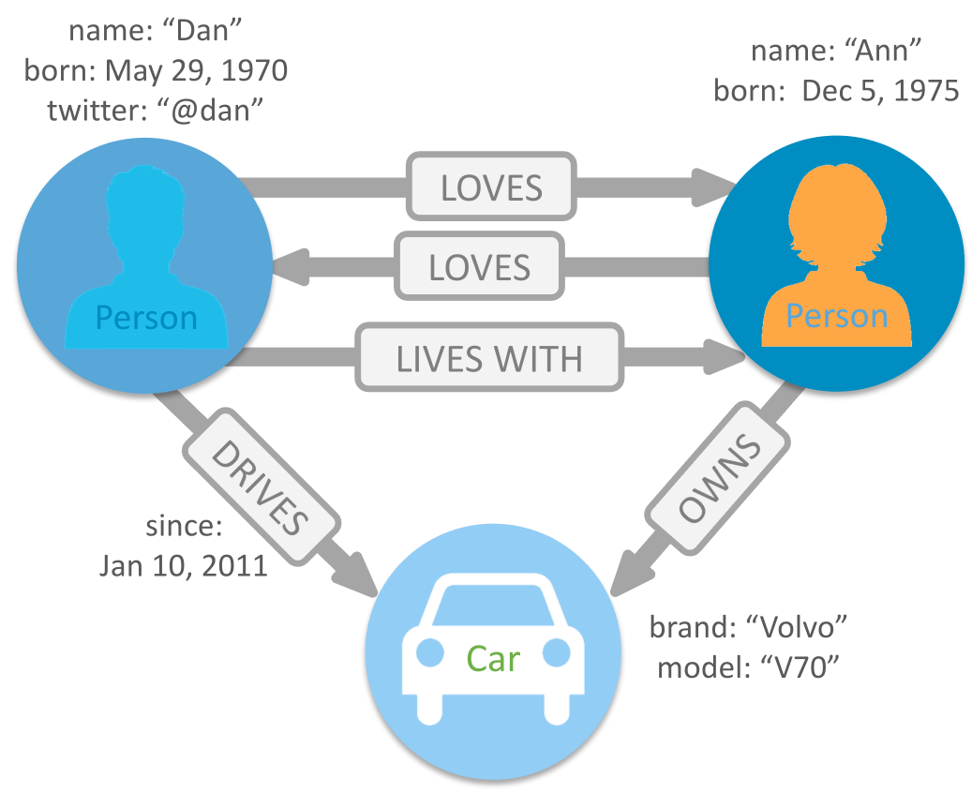

These types contribute to significant flexibility for a range of applications. NoSQL databases are well suited to handle typical challenges of big data, including volume, variety, and velocity. For these reasons, they are increasingly adopted by private industries and used in research. They have gained tremendous popularity in the last decade due to their ability to manage unstructured data.